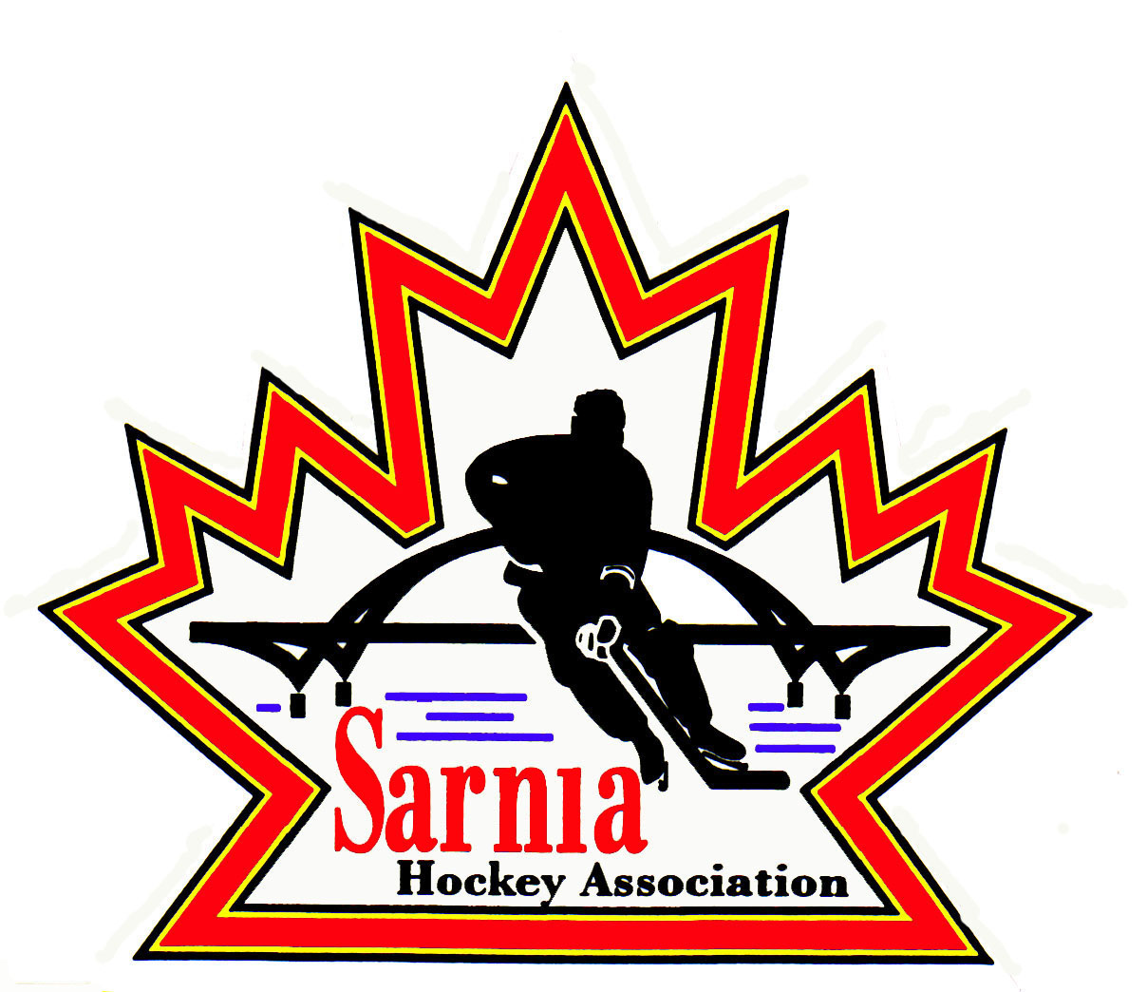

Sarnia Hockey Association

Minutes | Date: FEBRUARY 19, 2025 | time 7:00 pm

Meeting called by | Paul Walsh, President
Type of meeting | Regular
Secretary | Kelly Lane, Recording Secretary

Welcome | Paul Walsh, President, and meeting Chair welcomed everyone and called the meeting to order at 7:07 pm.

ATTENDANCE | Andrew Beasley, Jerry Bernardo, Alister Brown, Jeff Fogal, Terry Gray, Kelly Lane, Cris LaPointe, Linda Lauzon, John Mellor, Kyle Mellor, David Penner, John Ritchie, Wayne Scarrow, Kevin Taylor, Jason Teather, Paul Walsh, Barb Walsh  Regrets: Heather Amaral, Emily Brown, Ian Dunn, Chuck Ewart, Pat Forbes, Dan Hunt, Bonny Marcy, Don McGugan, Blake Morrison, Ted Pendle, Lesley Smith-Taylor, Tim Turner

ACCEPTANCE OF MINUTES | MOTION #250219-001  “That the Minutes from February 4, 2025, be accepted as presented.” (Bernardo/Ritchie)  Carried

TREASURER’S REPORT | No Report

BILLS TO BE PAID | MOTION #250219-002  “That the bills be paid as presented.” (J. Mellor/Gray)  Carried
  Recipient | Expense | Amount
  Dark Horse Goaltending  6X4 Goaltending  Paul Burgess Goaltending  Darren Rogers  U11 Select Team  Kyle Mellor  Alister Brown  Jerry Bernardo  Alliance  City of Sarnia  Village of Point Edward | U11 Rec, U11 A, U12 A, U13 A, U15 A, PD Clinic (Cousi funded)  U8/9 Rec, PD Clinic (Cousi funded)  New Rec goalies, attending 3 Friday sessions each (Cousi funded)  PEP Skills for U7, U9, U11, U13  50% Reimbursement for Alliance Championships  Silver Stick volunteer appreciation/opening ceremonies  Goalie equipment (some Cousi funded), coaches gifts  Alliance Semi AGM travel expenses  Silver Stick sanction fees  Room rentals  Rep/Rec ice  January Silver Stick ice  January Silver Stick ice | $ 2,100.00  $ 1,050.00  $ 315.00  $1,808.00  $ 610.00  $1,395.07  $ 3,064.66  $ 137.20  $2,318.00  $ 275.00  $94,319.60  $30,235.14  $ 5,209.94

PREVIOUS MEETING FOLLOW UP | HANDSHAKE POLICY:  - Alliance current policy is handshakes at the end of the game and at the end of a series. A lot of issues were happening at handshakes at the end of the game. If you don’t need to put players in a position for suspensions, why are we doing it.  - Alliance Rep Council wants our Association feedback as to whether we align with OMHA and GTHL.  - Alliance wants consistency with other member partners and there has been an increase in incidents of altercations during the handshake line.  - In good sportsmanship it should occur at the end of the game, but we need to discuss our position as an Association. It is hoped this change will cut down potential suspensions.  - Some players may not have the emotional capacity to process their emotions at the end of the game which could be a contributing factor.  - SHA will communicate our position to the Alliance at Rep Council meeting.  MOTION #250219-003  “That SHA recommend to the Alliance to change the handshake line to the beginning of the game and at the end of a playdown series.” (P. Walsh/J. Mellor)  Carried  U8/9 PLAYER MOVEMENT:  - Player movement within Alliance for U8/9 players will be up to the member partner.  - Alliance is asking our position on this.  - Will likely be an outflow of players for our Association.  MOTION #250219-004  “That SHA not support an inter Alliance player movement policy for U8/U9.” (P. Walsh/J. Mellor)  Carried  A/AA and B/BB TRYOUT REQUIREMENT:  - Current SHA policy is players must try out for AA first.  - Concept was our AA was our flagship teams and we wanted our best players trying out for our bests teams.  - We had some exemptions.  - With change in player movement, where we are allowing players from outside the City of Sarnia to tryout, there is a proposal that we sever the requirement to try out for AA first.  - We would have them identify on registration which team they plan on attending tryouts and then charge the same fee.  - We would remove this from our current policy.  MOTION #250219-005  “That SHA remove the requirement for trying out for AA first.” (P. Walsh/J. Ritchie)  Carried with 13 for and 3 opposed  - It was noted that there would be more work for BB Director to ensure that the coaches have the list and that they are registered through the HCR. This was not a previous requirement in OMHA.  - We will work with our Registrar to ensure lists are accurate before tryouts.  - This option would be good for players that want to play non-contact hockey.  - If we are focused on development, we want like skilled players on our AA.  - We have rarely had players not want to tryout for AA other than in older age groups that wanted non-contact.  - Tryout structure would not change, just the requirement of attending AA.  - A lot of our A players tryout for AAA first.  - It does provide opportunity for those players in older age groups that don’t want to try out for A.

REP DIRECTOR | - Opened up rep coach feedback forms and coaching applications. March 7 is closing date.  - A reminder was put up on our website.  - We don’t have a lot of applications yet. AAA ratified their coaches last night. We may see more coming in now.  - Plan on having a Zoom meeting with the Coach Selection Interview team on Monday. Will talk about the scope and structure of the interviews including timeline during the week of March 24th. Discuss length of interviews and questions. Providing them with feedback from previous coaches but not including the name of the person that provided the information.  - We can open up Coach feedback forms to Rec and Select next year as well.  - If you wish to attend this Zoom meeting let Paul Walsh know.

POLICY CHANGE | MOTION #250219-006  “To move Policy 1.01 to the approval stage.” (K. Taylor/B. Walsh)  Carried  - This has passed through PRAC process. This will be sent out to the SHA Board to review and will be voted on at next meeting on March 4. It is important for Board Members read and review this policy prior to the vote.  MOTION #250219-007  “To move Policy 3.06 to the approval stage.” (K.Taylor/A. Beasley)  Carried  - This policy includes an added definition of tampering.  - It includes a Team Official Commitment form.  - Expectations are laid out for team officials.  - Tampering prevention and prohibitive advertising.  - Revised policy to be sent out to the SHA Board for review. This will be voted on at our next meeting.  MOTION #250219-008  “To delete Policy 1.08 Abuse and Harassment entirely and delete all references to Policy 1.08 in the Sarnia Hockey Policy Manual.” (K. Taylor/B. Walsh)  Carried  - Stakeholder References to the new HC & OHF policy are found in SHA Policy 1.01, 2.03, 3.06 and 3.07 (and potentially 2.07-Investigations).  - Policy 1.08 Harassment and Abuse is outdated & obsolete.  MOTION #250219-009  “That we approve Policy 2.07 Investigation Procedure for implementation.” (K. Taylor/Fogal)  Carried  - Reason for change is to add to Policy Manual immediately. Aligns SHA investigative procedures with OHF, Hockey Canada and Alliance.  - The policy maintains compliance with governing bodies.  - This policy will be brought to the next meeting for PRAC.

ICE DIRECTOR | - Few rescheduled games from the weekend due to weather.  - Working on Final Days scheduling.  - Provided Silver Stick blackout dates to the City.  - If there are other dates, we need to provide them.  - Trying not to take team practices away.  - Working with ice schedulers and teams forfeiting games versus rescheduling.  - Everyone is tight for ice and discussing starting season earlier.  - Winter Classic – separating U7/9 divisions and keeping at Christmas break and moving U11 and above to Feb 20-22. To get better participation and bring in more teams. This would allow opportunity to add more teams in each division. At this point only London has a tournament that weekend and it is a Select tournament. May also help with volunteers.  - There is a question however about ice availability in February with playdowns starting.  - Talked about doing skill event at the Winter Classic. Issue with lack of referees.  - There may be a reduction of rep games next year.  - Need further discussion re dates for Winter Classic.

PHOTOGRAPHY DIRECTOR | - Team pictures being completed.  - Discussions with Sarnia Ice Hawks and suggested we could do this annually and they were in agreement.  MOTION #250219-010  “That SHA provide an honorarium to Sarnia Ice Hawks in the amount of $500.00.” (J. Mellor/Lauzon)  Carried

AAA Report | - Ratified coaches except for U18.  - Selecting that team in the spring.

CORRESPONDENCE | - SHA President received an email from Amy Carlaw of Sarnia Junior Lady Sting thanking our organization for making ice available at PASA 1 on February 8 for the Sarnia Junior Lady Sting Spirit Day. The Lady Sting had made a request to SHA and AAA to make available the PASA 1 ice on Feb 8 and we were able to reschedule teams.  The Lady Sting appreciated the partnership between the 3 organizations and the flexibility shown to allow them to host a celebration of girls hockey. They plan on doing it next year and will black out the ice with the City.  - Jeff Needham has decided to step down from his position as Skills Director for SHA. He thanked the board for the support provided.

NEW BUSINESS | 2025/26 BOARD POSITIONS UP FOR ELECTION:  - SHA President identified what positions are up for election this year:  BOARD POSITIONS FOR ONE-YEAR APPOINTMENT:  - Board Members whose positions are up for election are asked to contact Nomination Committee members Wayne Scarrow or Paul Walsh with their intentions to run again or to identify interest in another position.  CONDOLENCES:  - Ryan Trusler passed away on February 5. He was a long-time supporter of hockey and a previous Board member of AAA hockey.  - Bonny Marcy’s husband Ed passed away on Feb 12. Celebration of Life is scheduled for February 20 at Stokes Inland. We will send a condolence card to the Marcy family.  ALLIANCE AGM:  - Alliance AGM is scheduled for June 20-21 at Four Points Sheraton in London.  - Golf at Fire Rock on June 20 with dinner following at the hotel.  - June 21 is the AGM meeting from 8:30am to noon.  - If interested in attending, please contact Paul Walsh.  - We are allowed 10 delegates.  - Registration deadline is May 31.  COACH AND MANAGER OF THE YEAR:  - Rec Directors to provide name of Coach of Year for Rec Divisions.  - A/AA and B/BB Directors to provide name of Coach and Manager of the Year for A/AA and B/BB.  - Names to be submitted to Alister Brown by March 14.  VOLUNTEER OF THE YEAR:  - Need nominations for Volunteer of the Year.  - This will be put out on our website. Need nomination and short paragraph on what they have done.  - Submit to Volunteer of the Year to Selection Committee that consists of Wayne Scarrow, Barb Walsh and Jerry Bernardo.  NEXT MEETING:  - Next meeting is Tuesday, March 4, 2025 at Clearwater Arena.
  POSITION | CURRENT MEMBER
  First Vice-President | Kevin Taylor
  Vice-President Recreational League | Jerry Bernardo
  Director of Recreational League U15 | Dan Hunt
  Director of Recreational League-U11 | David Penner
  Director of Recreational League U6/U7 | Brendan Douglass
  Director of Recreational League Foundations | Jason Teather
  Director of A/AA Representative Teams | Terry Gray
  Development/Skills Director | Vacant
  Ice Director/Scheduler | Linda Lauzon
  Recreational League – Tournament Director | Jeff Fogal
  Sponsorship Director – Recreational Teams | Jerry Bernardo
  Recreational League Referee Director | Ian Dunn
  Director of Mental Health | Tom Babcock
  Website Director | Andrew Beasley
  Equipment Director Representative Teams | Tom Babcock
  POSITION | CURRENT MEMBER
  Director at Large-AAA Representative | Tim Turner
  Director at Large-AAA Representative | Cris LaPointe
  Director at Large-Select Teams | Don McGugan
  Director at Large-Silver Stick Tournament | Paul Douglass
  Director at Large | John Ritchie
  Director of Fundraising | Bonny Marcy
  Alliance Rep Council | Paul Walsh
  Alliance Rec Council | Jerry Bernardo
  Director of Recreational League U18-21 | Vacant

adjournment | MOTION #250219-011  “That the meeting be adjourned.” (Scarrow/K. Taylor)  Carried

Paul Walsh Kelly Lane
President Secretary

